**GitHub Copilot + Visual Studio 2022**

**We use GitHub Copilot to generate code using AI. It also help to improve our code efficiency and quality. Below are the steps to enable GitHub Copilot in Visual Studio 2022.**

* Create GitHub Account
* Install Visual Studio
* To enable GitHub Copilot follow below steps:
  + Open Visual Studio
  + Select Extensions > Manage Extensions
  + Search for "GitHub Copilot" or "GitHub Copilot Chat"
  + Select the extension and click Download
  + Restart Visual Studio
* Link Git Hub Account in Visual Studio by clicking on Github Copilot button
  + Open Visual Studio
  + Go to the GitHub Copilot tab
  + Click Sign in with GitHub
  + Authorize the extension to access your GitHub account

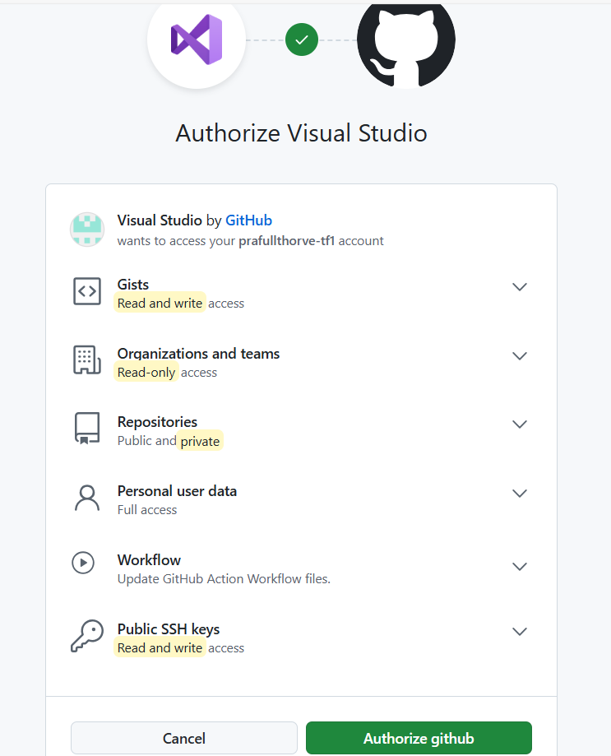

And click on Start Using Copilot Free button.

* Now Restart Visual Studio and open project you want to work on and click on

View >> Github Copilot Chat

It will open window as follows where we can put query or statements to generate code.

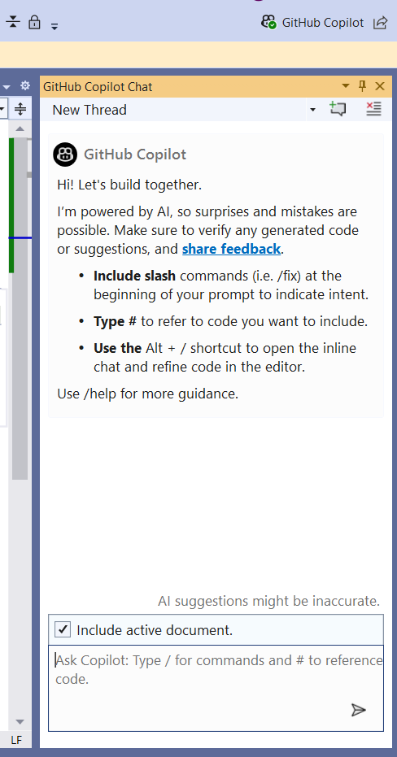

As shown in above screenshot, we can put command for code in few ways:

1. Github Copilot Chat Window:

As shown in above screenshot, you can post command in chat area and get response in same window.

From Chat window you can Preview, Copy code, or insert in new file.

1. Inline Command:

Put // with command for expected code block

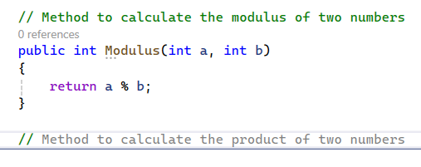

Once you put any inline command for code it shows code automatically that is called as GHOST TEXT, we can click TAB to accept the code.

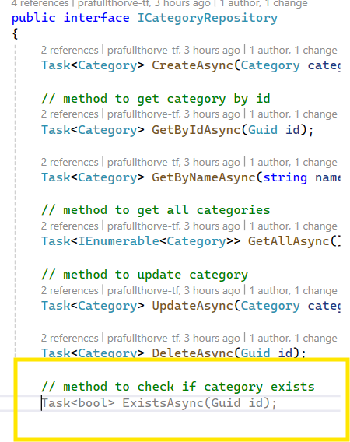

1. Use Alt + /

Like below you will get prompt to enter command.

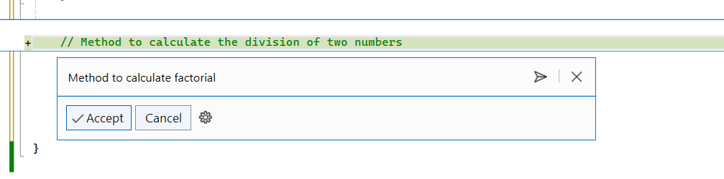

Once you receive response it will show as follows, if code is correct you can click on Accept button to get it available in your code block.

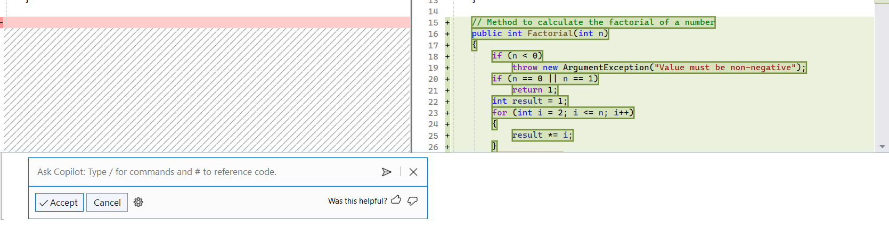

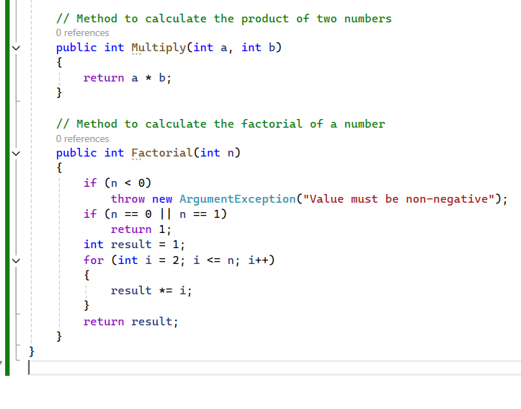

>> There are few more feature in Github Copilot Chat window using Include / as follows:

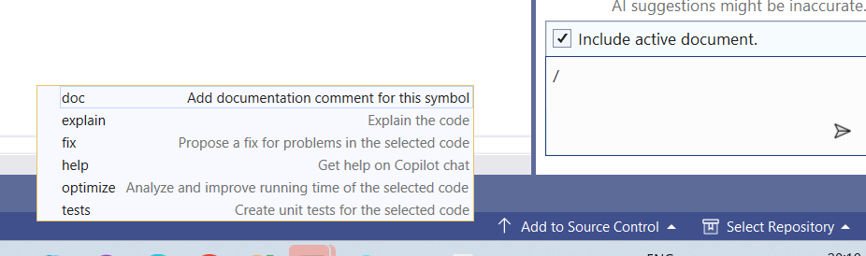

* We can generate and add documentation comment.
* We can ask to explain code/method.
* We can ask for fix for problems in selected code.
* We can open help Gitbub copilot chat.
* We can optimise code using copilot chat.
* We can generate Tests for selected code.